Backend

Frontend

Middleware is it at edge component

Server side rendering

Bundling in next js: very intelligent code splitting technology

It is very messy question for us what is vm, containers and server less

Edge computing

Next and react

For reason the react js was introduce

React is a library and which has very much complications in routing, slow because of lack of server side rendering

**Vercel**

Vercel build on AWS Lambda which give our customers the tools to iterate and scale quickly.

Accout is free of charge for forever and non-commercial use.

Nextjs is deployed at vercel.

**Next js**

Turbopack is successor to webpack.

Define webpack.

**Turbopack**

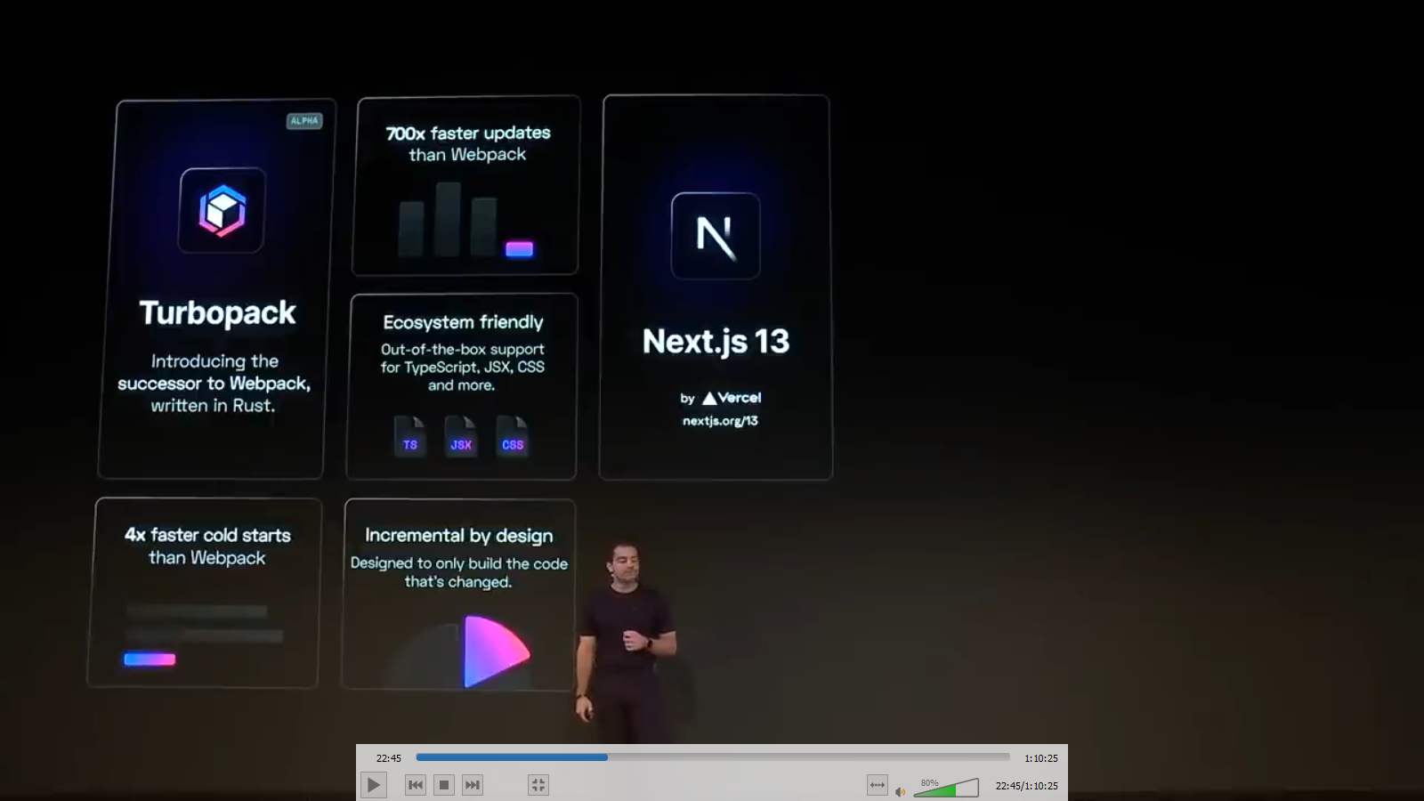

Vercel provides the incremental by design means design to only build the code that is changed. Like we see the incremental page directory.

Due to vercel, your react pages become optimal serverless and edge infrastructure. Which deliver dynamic at speed, availability and cost effectiveness of static.

Nextjs provide the convenient way Routing, data fetching and redering react app.

Nextjs and vercel provides one big ecosystem and we are able to focus on a lot of experimentation and iterations.